Inserting Clip Art

To insert clip art using a version of Word greater than Word 2000, do the following. (Please note that the same pictures may not be available to you. Choose any picture you like.)

Click Insert > Picture > Clip Art from the menu bar. A side bar will appear like the following:

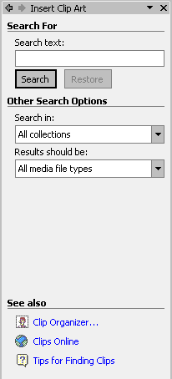

Click on the Clip Organizer at the bottom:

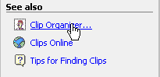

The clip art collection dialogue box will open:

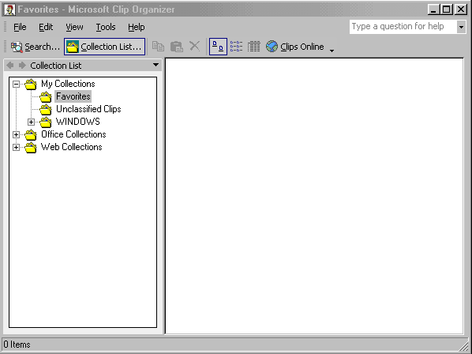

Click on Office Collections to select it. Then click on the plus symbol next to it:

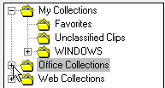

A list of clip art will appear. In the box below, the Animals category is selected:

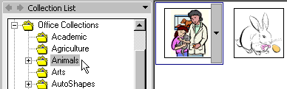

Move your mouse to the image you want, and a down-pointing arrow will appear next to the picture:

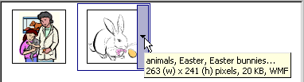

Click the arrow to see the menu:

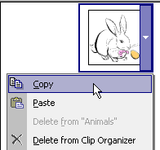

Select Copy from the menu to copy the picture to the Clipboard.

Close the Clip Organizer by clicking File > Exit:

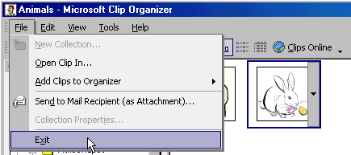

When you click Exit, you’ll see the following message box appear:

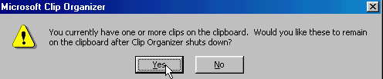

Click the Yes button to keep your picture on the Clipboard.

When you get back to Word, click the Edit menu. Then select Office Clipboard:

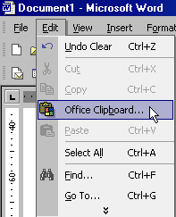

A side bar will then appear when you click Office Clipboard. You should see the picture you selected appear on the side bar:

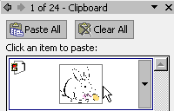

Click on your picture and it will be pasted to your document:

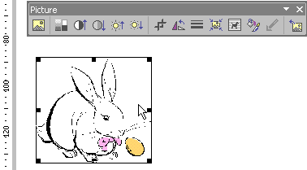

The image can then be resized and moved, as outlined on page 134 of your course book.

